Projects Documentations

Project Overview: Insurance Web applications for insurance companies to provides customers to case management and their final report implementations .
Technology Stack : Php Laravel, Mysql, Dart ,Bootstrap
System Architecture :
Modules:
1. User Management
2. Insurance Company Management
3.Questionnaire List Management
4 .Case Management
4.1-Pending Case, Assigned Case, Completed Case
5.Report Management
6.Odometer Reading
7.Approvel Request
8.Password Request
9.Company Management
10.Make Final Report

Admin Login
- https://insurance.niveosys.org/login
username: admin@mail.com
password: Admin@123
- https://insurance.niveosys.org/home
This is the Dashboard Page for the case list report and their filter wise date custom picker and date periods and graphically represents case count as pending,approved, and completed case.

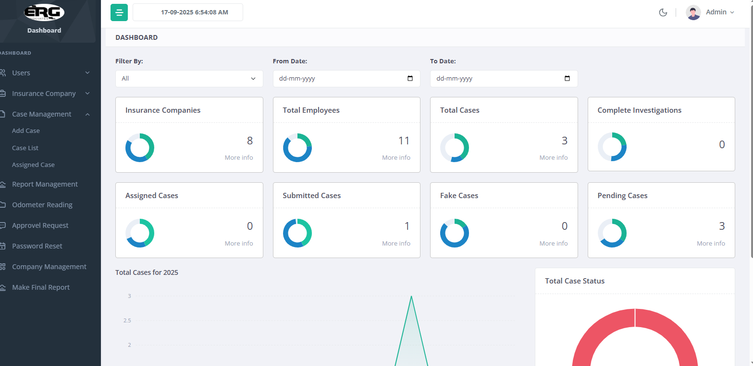

- User management
List out user list as type field agent and sub admin and an option to create a new users, also block options in user list and updates their list.

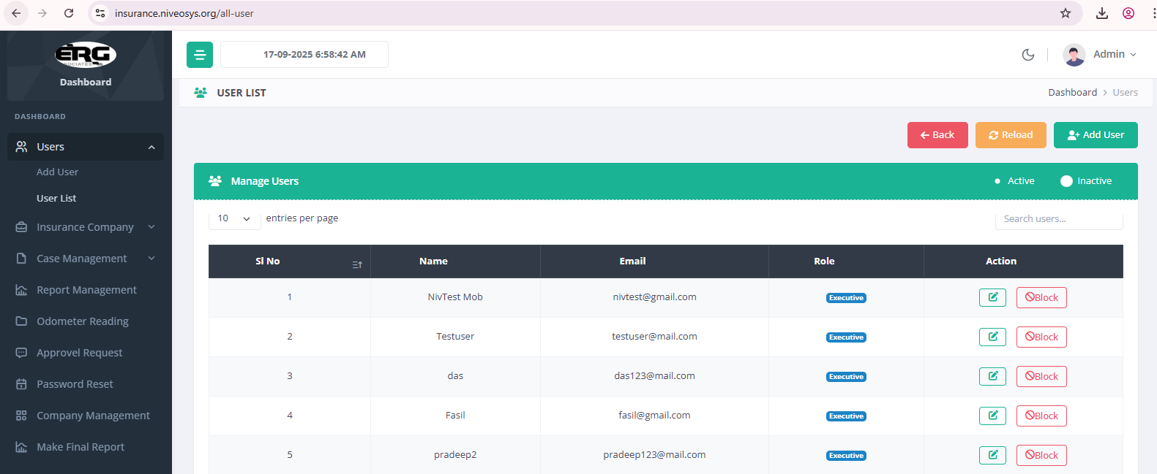

- Inusrance Company Management
List out insurance companies and create new companies for selecting particular questions can be checked with data category and select the templates to make final reports generating.

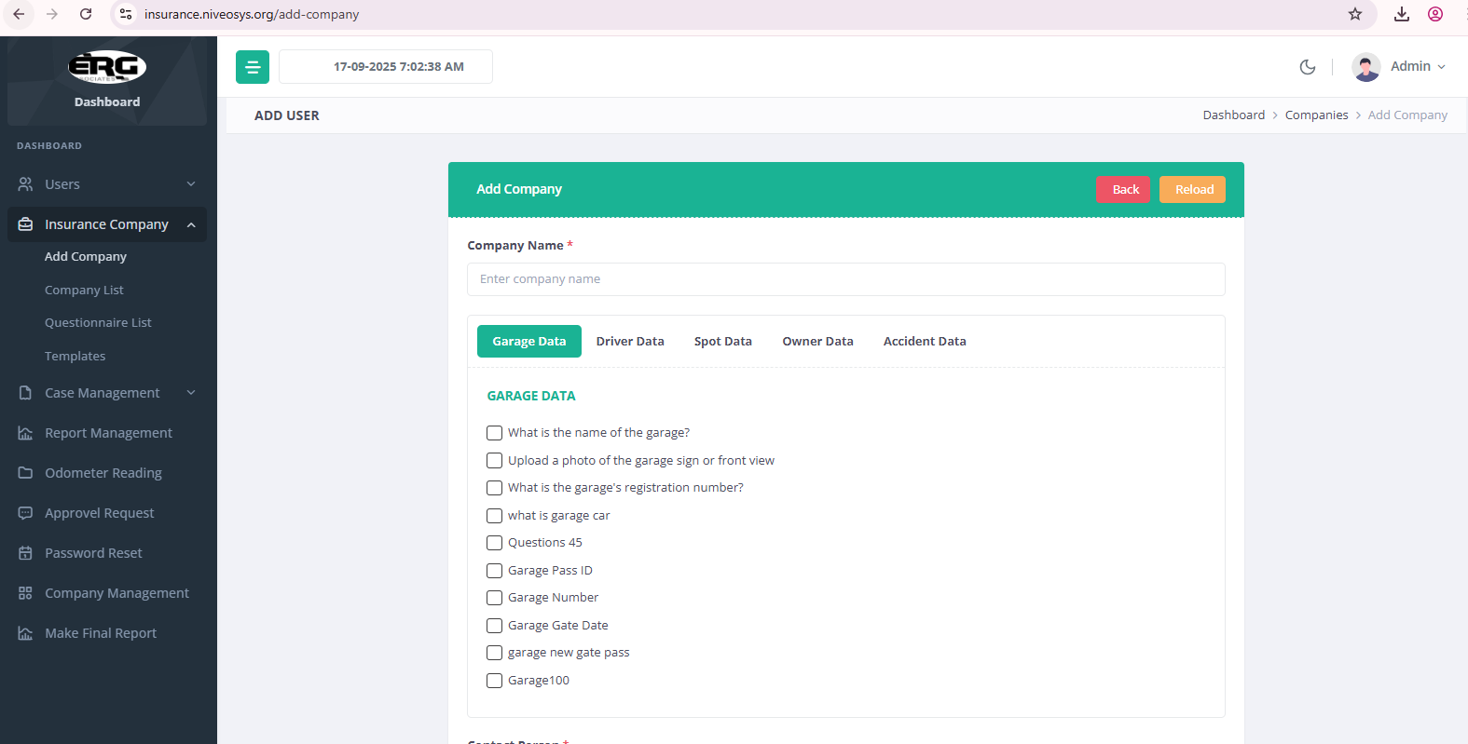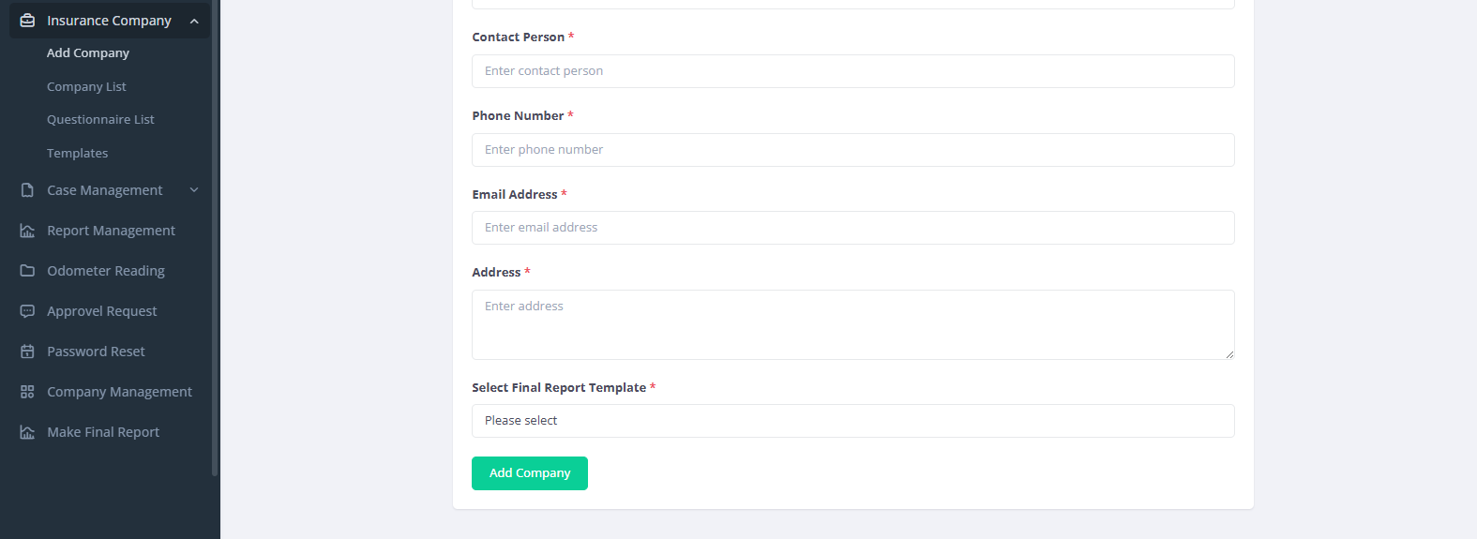

- Questionnaire List
Manage new Questions or exisiting questions can be manage with their selected data category is providing like as Garage Data, Driver Data, Spot Data, Owner Data and Accident Person Data.

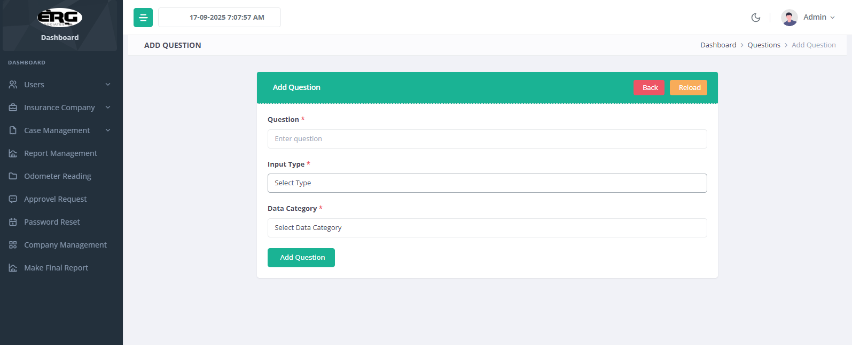

- Case Management
For creating new case list with case type as OD and MACT and choose to select as the executives for assigned case with which data category of particular incidents can be assigned.

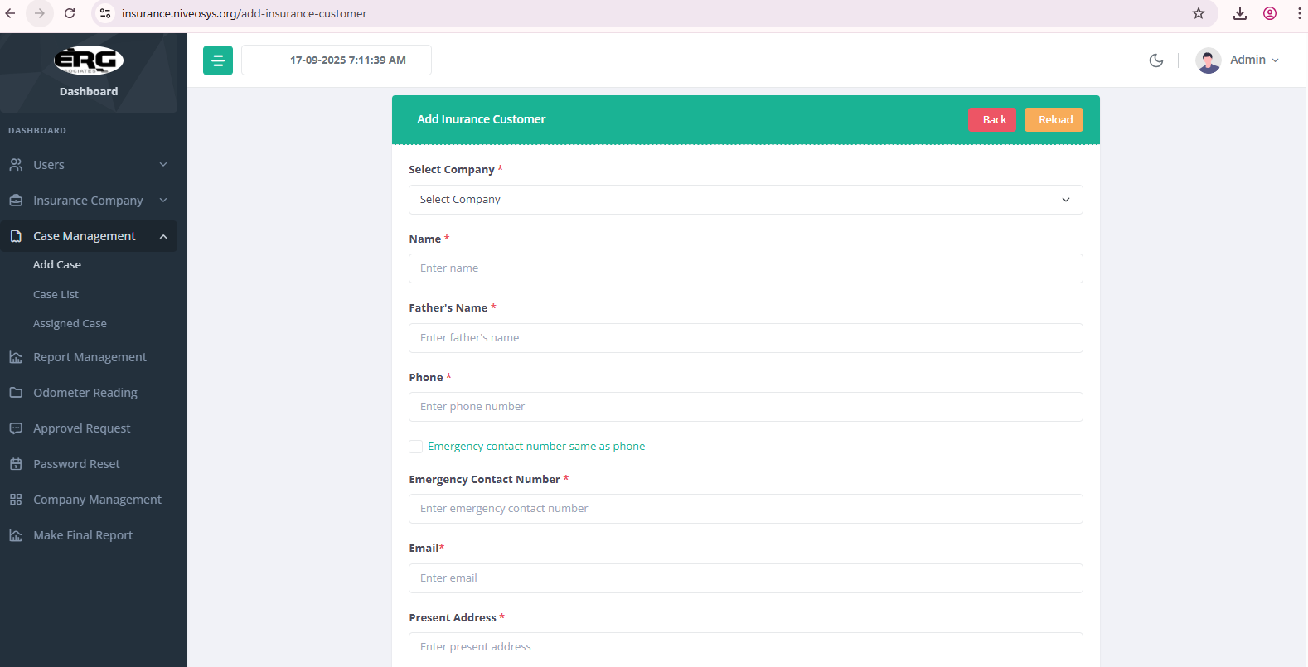
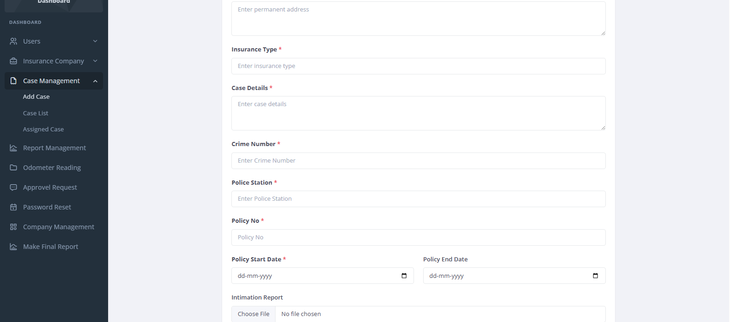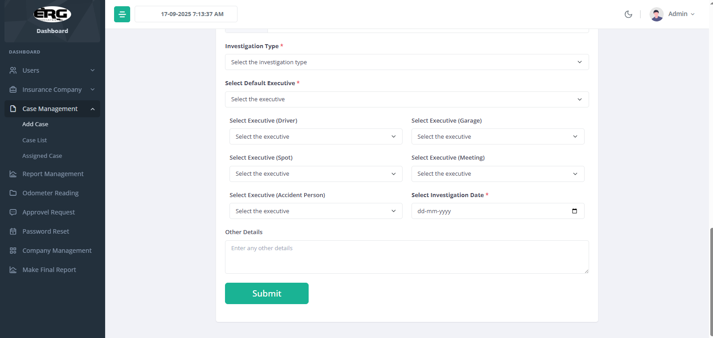

And case list management shows their case status is provides with all case details is shows and download their intimation reports.
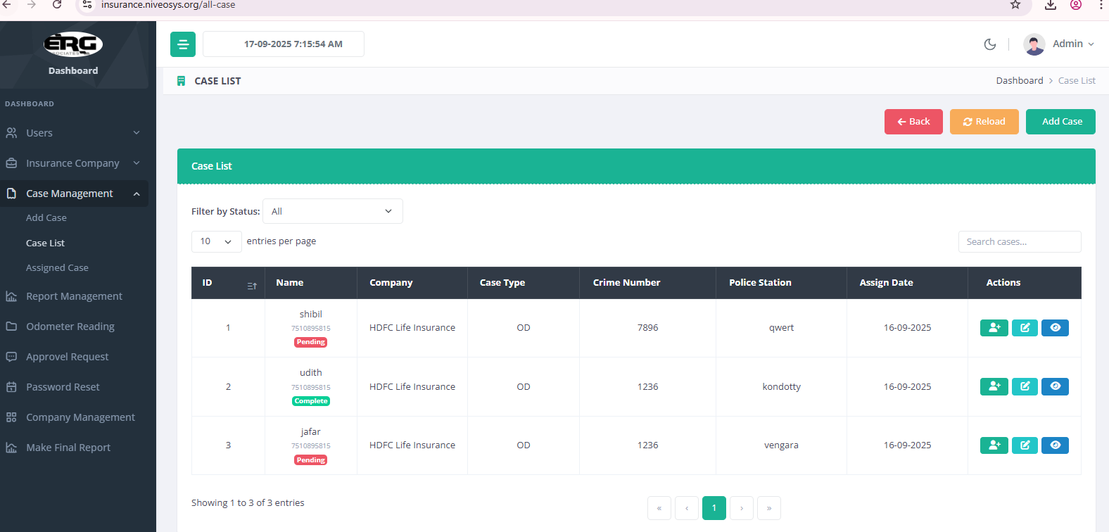

Assigned Case List is also shows for assigning pending case can be assigned to particular field agents.

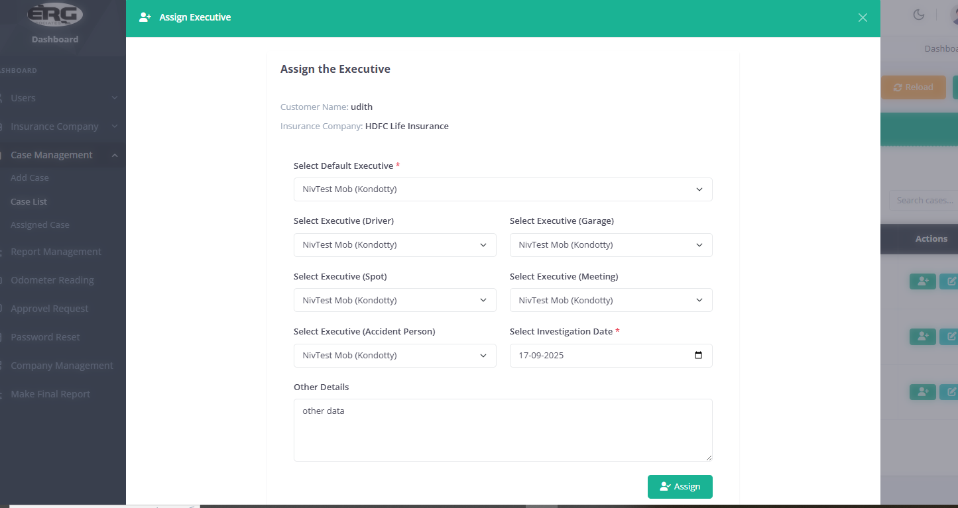

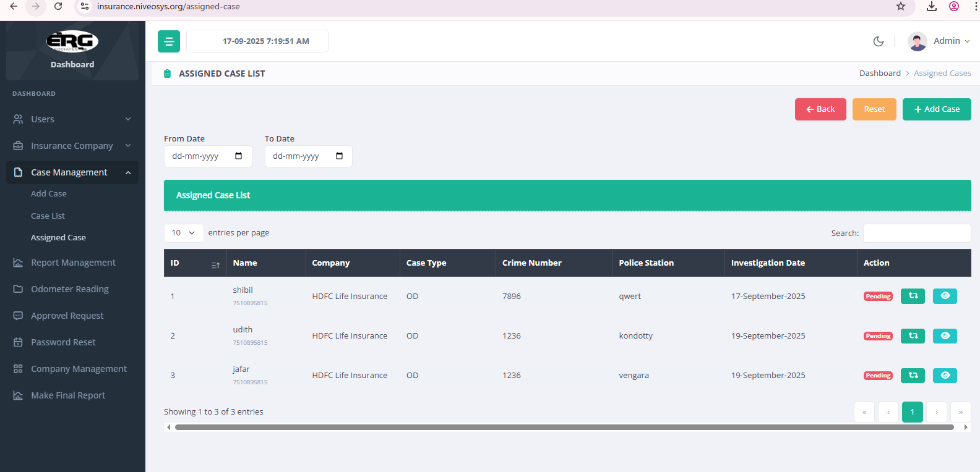

Here is the assigned case list and also here provides date wise filter options to data can be filter as date wise.

- Report Management

Here is the particular report request list is providing for particular case data, here also provides filter options in date picker in their report request list.

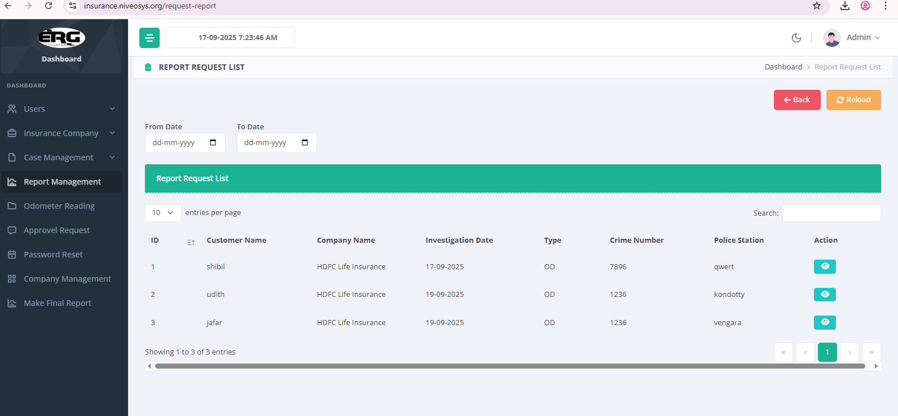

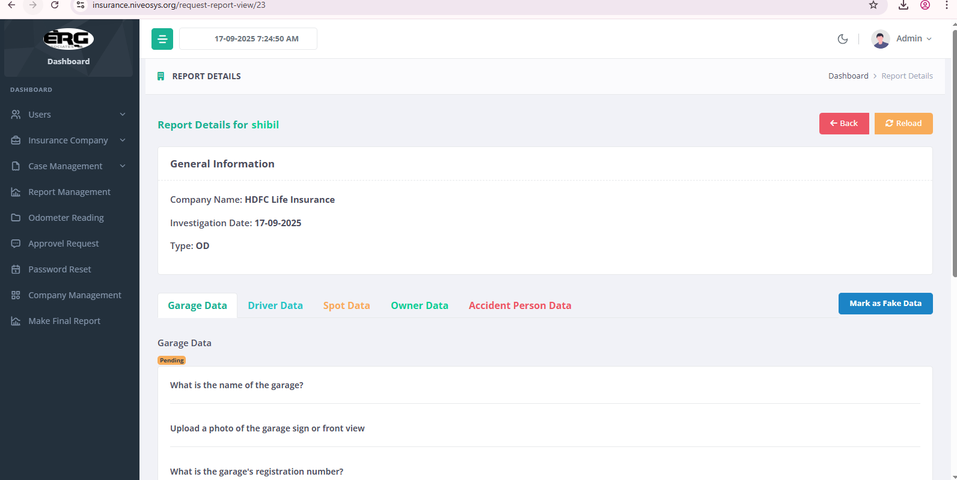

Report request list view pages can be provides the question for specific data category and updates the specific results for their category to select radio button to updating and save their data. Also their specific results can be moved to final report to select checkbox as select this data as moved to final report. Also here specific case mark as fake is the option proving here.

- Odometer List
List out all odometer data with check out and check in for specific user and their reading date.

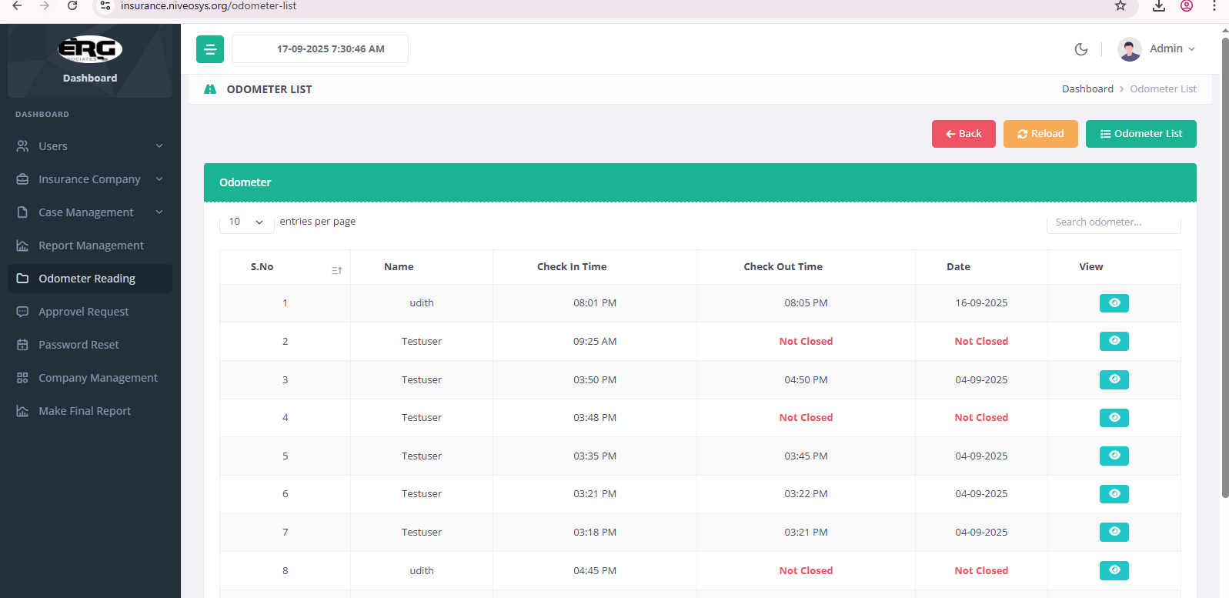

- Approvel Request
Is this an approvel request is proving for user login in mobile app to request approve for login

- Password Request
Is this an pending password reset request list is providing here

- Company Management
For Managing company for updating their list and logos.

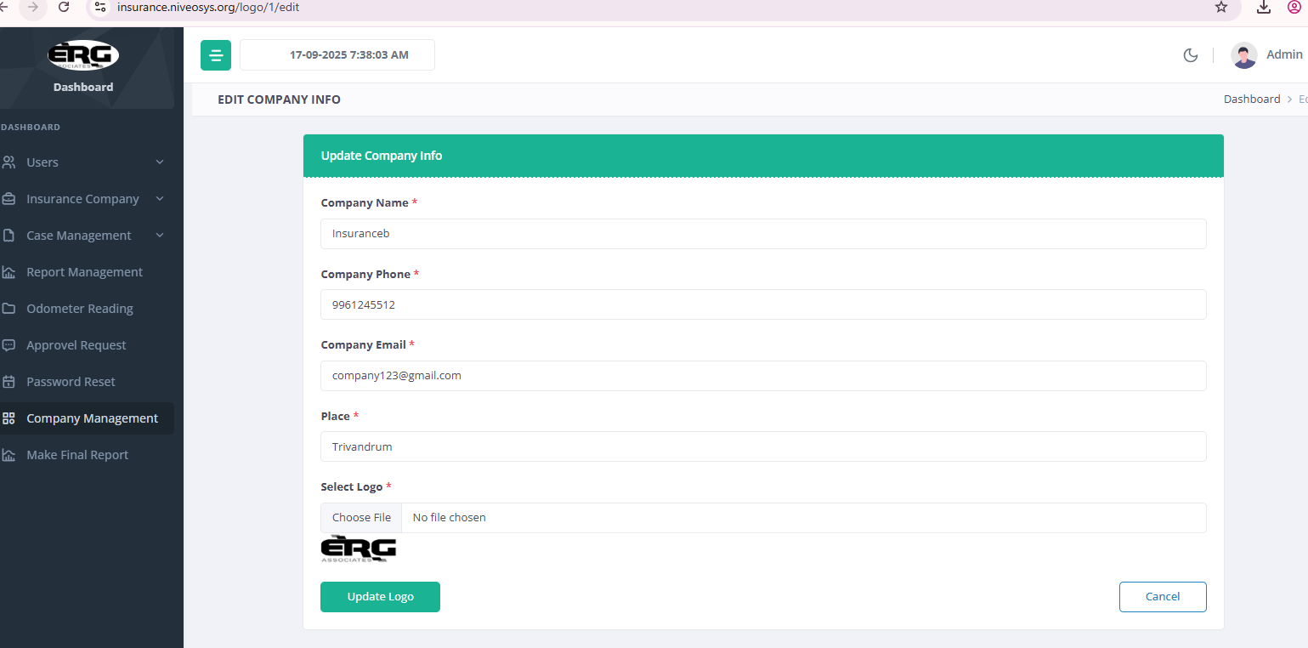

- Make Final Report
Here is to make an final report is downloaded for the selecting specific answers to select in report management and here to downloaded their data as in pdf formats.

